Mobile App Development Project 3

Project Description

My third apple application and project 3 is going to be much more advanced application than any of mine from before. I have decided to make the perfect “study abroad application” that connects users with texting, email, pictures/videos, and Facebook connections. Since while abroad I won’t be able to use cell phone data, all of these will work as long as I have Wi-Fi. Luckily, there are frameworks for all of these.

Pseudo code – 1st Level

Take Picture Controller

interface Appviewcontroller: UIViewController

@proptery (strong,nonatomic) Outlet \*imageview

* action takephoto
* action select

Text View Controller

Import message framework

Table view controller

Compose message

Social Controller 3

Import social framework

Facebook

Twitter

Email

New email

Attach

Send

Visual Design

My application with have a tab bar with 4 different views to switch between with easily recognized icons.

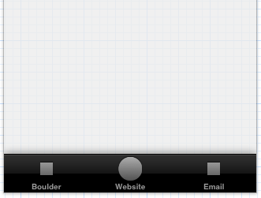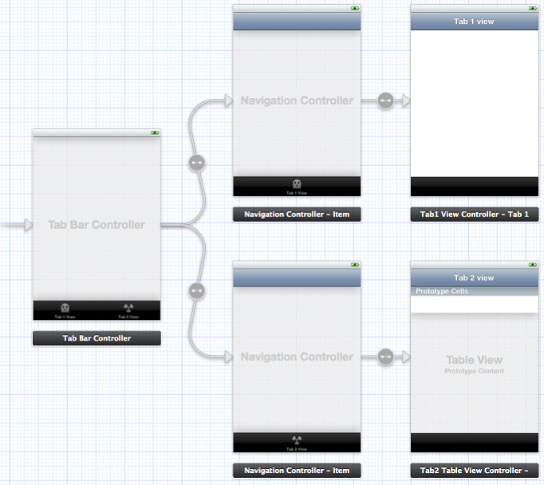

Testing

I am going to test our application step by step on the simulator that is provided by xcode. Then when everything looks awesome and works, I going to download it to an iPad and test our application on there. Voila!